Exercise 1: Inventory Management System
Scenario:
You are developing an inventory management system for a warehouse. Efficient data storage and retrieval are crucial.
Steps:
- Understand the Problem:
  - Explain why data structures and algorithms are essential in handling large inventories.
  - Discuss the types of data structures suitable for this problem.
- Setup:
  - Create a new project for the inventory management system.
- Implementation:
  - Define a class Product with attributes like productId, productName, quantity, and price.
  - Choose an appropriate data structure to store the products (e.g., ArrayList, HashMap).
  - Implement methods to add, update, and delete products from the inventory.
- Analysis:
  - Analyze the time complexity of each operation (add, update, delete) in your chosen data structure.
  - Discuss how you can optimize these operations.
- Output:
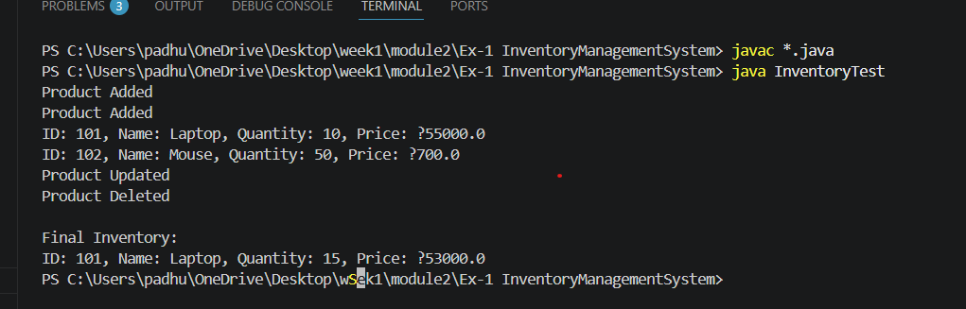
Exercise 2: E-commerce Platform Search Function
Scenario:
You are working on the search functionality of an e-commerce platform. The search needs to be optimized for fast performance.
Steps:
- Understand Asymptotic Notation:
  - Explain Big O notation and how it helps in analyzing algorithms.
  - Describe the best, average, and worst-case scenarios for search operations.
- Setup:
  - Create a class Product with attributes for searching, such as productId, productName, and category.
- Implementation:
  - Implement linear search and binary search algorithms.
  - Store products in an array for linear search and a sorted array for binary search.
- Analysis:
  - Compare the time complexity of linear and binary search algorithms.
  - Discuss which algorithm is more suitable for your platform and why.
- Output:
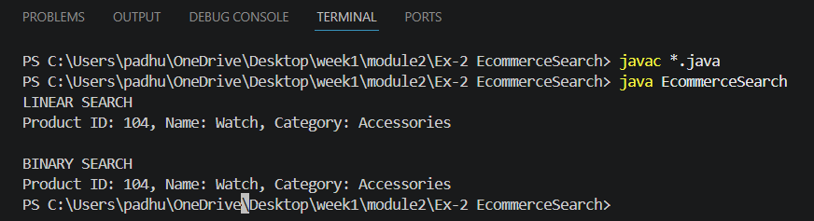
Exercise 3: Sorting Customer Orders
Scenario:
You are tasked with sorting customer orders by their total price on an e-commerce platform. This helps in prioritizing high-value orders.
Steps:
- Understand Sorting Algorithms:
  - Explain different sorting algorithms (Bubble Sort, Insertion Sort, Quick Sort, Merge Sort).
- Setup:
  - Create a class Order with attributes like orderId, customerName, and totalPrice.
- Implementation:
  - Implement Bubble Sort to sort orders by totalPrice.
  - Implement Quick Sort to sort orders by totalPrice.
- Analysis:
  - Compare the performance (time complexity) of Bubble Sort and Quick Sort.
  - Discuss why Quick Sort is generally preferred over Bubble Sort.
- Output:
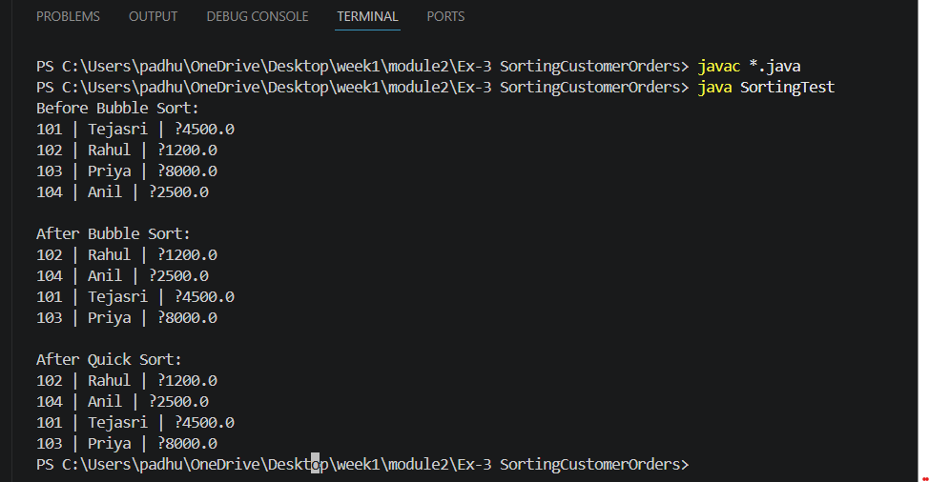

Exercise 4: Employee Management System
Scenario:
You are developing an employee management system for a company. Efficiently managing employee records is crucial.
Steps:
- Understand Array Representation:
  - Explain how arrays are represented in memory and their advantages.
- Setup:
  - Create a class Employee with attributes like employeeId, name, position, and salary.
- Implementation:
  - Use an array to store employee records.
  - Implement methods to add, search, traverse, and delete employees in the array.
- Analysis:
  - Analyze the time complexity of each operation (add, search, traverse, delete).
  - Discuss the limitations of arrays and when to use them.
- Output:
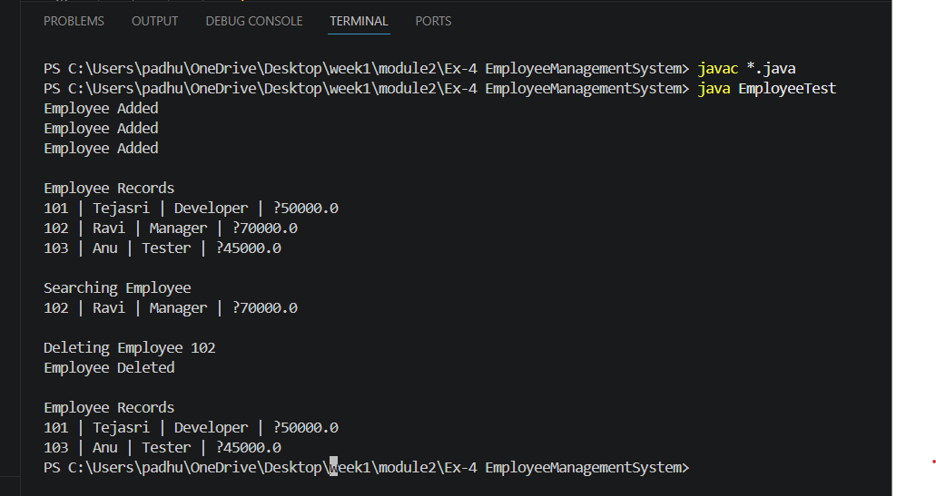
Exercise 5: Task Management System
Scenario:
You are developing a task management system where tasks need to be added, deleted, and traversed efficiently.
Steps:
- Understand Linked Lists:
  - Explain the different types of linked lists (Singly Linked List, Doubly Linked List).
- Setup:
  - Create a class Task with attributes like taskId, taskName, and status.
- Implementation:
  - Implement a singly linked list to manage tasks.
  - Implement methods to add, search, traverse, and delete tasks in the linked list.
- Analysis:
  - Analyze the time complexity of each operation.
  - Discuss the advantages of linked lists over arrays for dynamic data.

- Output:
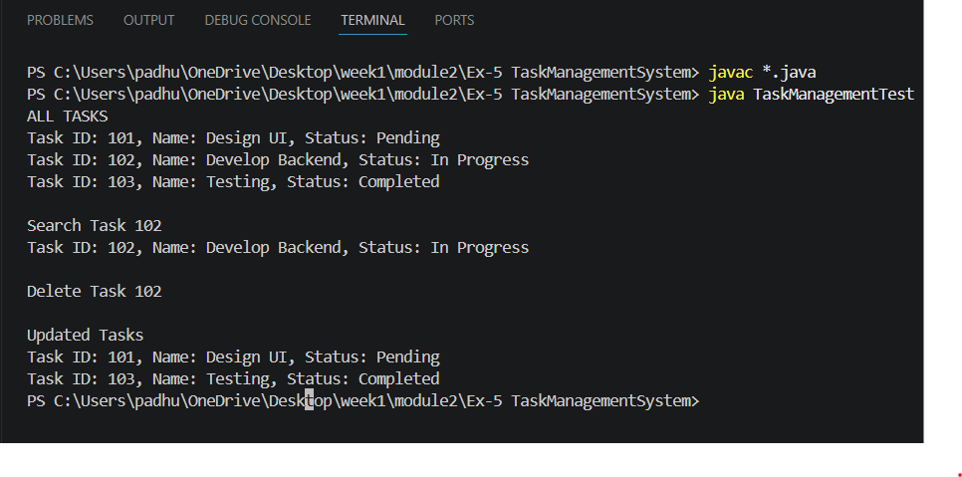

Exercise 6: Library Management System
Scenario:
You are developing a library management system where users can search for books by title or author.
Steps:
- Understand Search Algorithms:
  - Explain linear search and binary search algorithms.
- Setup:
  - Create a class Book with attributes like bookId, title, and author.
- Implementation:
  - Implement linear search to find books by title.
  - Implement binary search to find books by title (assuming the list is sorted).
- Analysis:
  - Compare the time complexity of linear and binary search.
  - Discuss when to use each algorithm based on the data set size and order.
- Output:
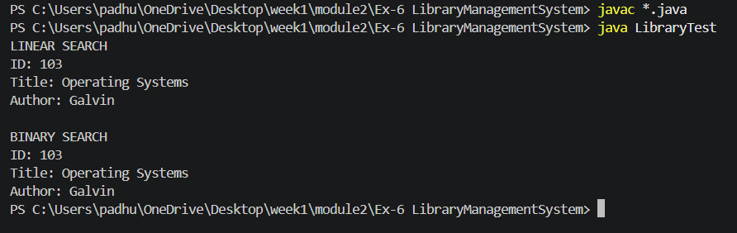

Exercise 7: Financial Forecasting
Scenario:
You are developing a financial forecasting tool that predicts future values based on past data.
Steps:
- Understand Recursive Algorithms:
  - Explain the concept of recursion and how it can simplify certain problems.
- Setup:
  - Create a method to calculate the future value using a recursive approach.
- Implementation:
  - Implement a recursive algorithm to predict future values based on past growth rates.
- Analysis:
  - Discuss the time complexity of your recursive algorithm.
  - Explain how to optimize the recursive solution to avoid excessive computation.
- Output:
